DIS-Eur-Italy-Acheulean-ca. 1.8 Ma BP-San Giorgio-Susan Murcott-6-21-2015

Acheulean hand axe, limestone, 9.3 cm. wide, 12.8 cm. high, 2.7 cm thick, ca. 1.8 Ma B.P. Homo Neaderthalensis. Surface collected by Susan Murcott, San Giorgio Italy north of Monte Poggiolo site of a prominent Acheulean site

Acheulean hand axes have been found over much of Europe, Africa, and Asia; from the British Isles to southern Africa, and from the Iberian Peninsula (Spain/Portugal) to China. The Acheulean hand axe industry is significant because it marks a conceptual shift in the making of stone tools which could be linked to a common cognitive development in Homo Erectus and early Homo Sapiens. Earlier stone tools were simple pebble tool technology, where a few random flakes were chipped off of river cobbles to form a sharp edge. The hand axe, however, is a shape within a stone. Its creation required many carefully planned flakes to be removed, which modified the entire stone. Furthermore, it is a symmetrical shape that was emulated and imitated over great distances for over 1 million years. Large or small, the same tear-drop shape was produced. This suggests that a mental template was followed, indicating planning and purpose in the mind of the maker, in addition to sophisticated knapping skills.

As this tear-drop template spread across thousands of miles so did the putative development of common intellectual structures such as language acquisition and communication in early hominids. While there is a basic paradigm in the shape of the Acheulean had axe, at least four different Acheulean modal shapes based on geographical distribution: Africa, India, Israel and England (Wynn and Tierson. 1990). The core-Flake tool Industry of this Acheulean hand axe is possibly derivative of the African modal shape and which is associated with Monte Poggiolo in northern Italy and its find site, San Giorgio.

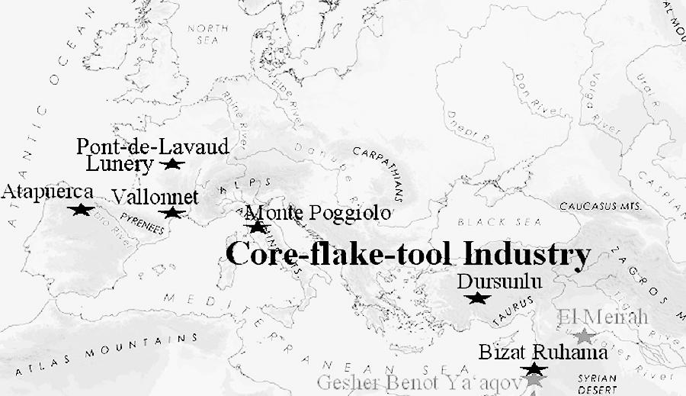

Fig. 1. Map of the core-flake -tool Industry of the Acheulean culture 1.8-1.0 Ma (Million years ago). After Doronichev 2010:333,fig. 6.

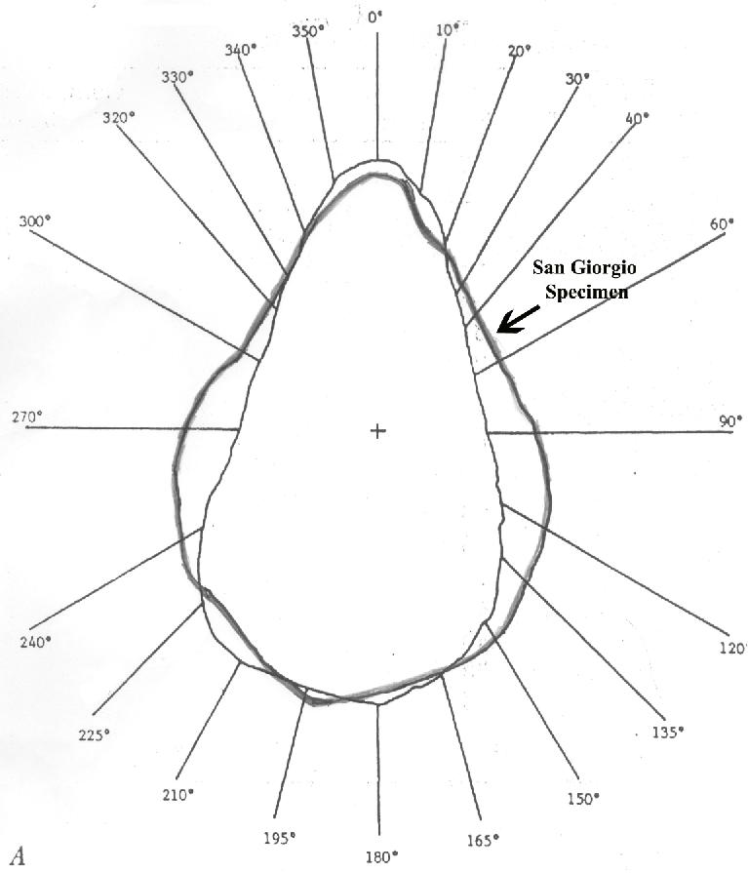

Fig. 2. Polar coordinates measure the shape of the San Giorgio hand axe against the background of an unnamed hand axe.. The San Giorgio specimen is outlined in bold black.

If this is the case then its shape reflects an Acheulean tradition distinct from that of the British Isles, as well as from that of the near East (Israel). In the meantime another culture inserted itself between the western African Acheulean and the Near Eastern Acheulean, the Mousterian a style of predominantly flint tools (or industry) associated primarily with *Homo neanderthalensis* and dating to the Middle Paleolithic

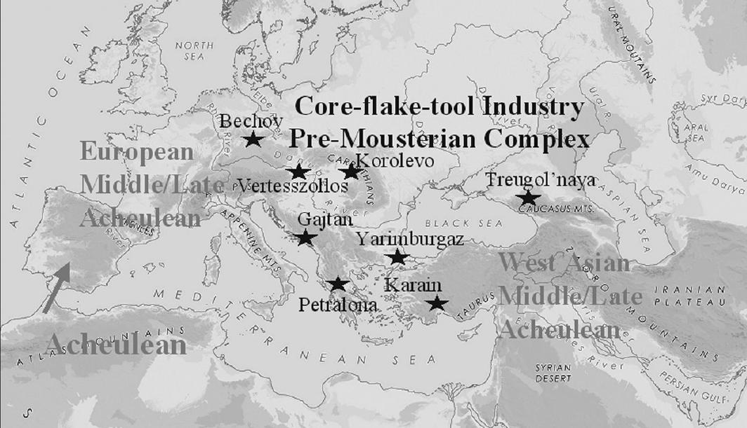

Fig. 3. Diffusion of the Acheulean into south-western Europe while it is separated from the pre-Mousterian Comp0lex in the area from the Rhine River down the Danube River to the Black Sea, 0.7-0.3 Ma. After Doronichev 2010:334,fig. 7.

Furthermore, since raw material constrains the shape of bifaces (Jones 1981), this particular limestone specimen reflects the application of a basal grinder which was used to shape the specimen into its traditional "tear drop" shape. This specimen was surface collected by Susan Murcott on the ridge overlooking the Fravica Valley in northern Italy north of Milan and just north of Monte Poggiolo.

Importantly, Murcott also surface collected an abrader near the hand axe that could have been used to shape the limestone of the hand axe: abrading is obvious in the upper left quadrant and the base of the specimen, while flaking is obvious in the upper right quadrant. Therefore, the two specimens, the hand axe and the abrader-flaker, may have been part of the ancient hunter's toolkit as he watched the game in the valley below while he finished shaping his weapon.

Doronichev, V. and Liubov Golovanova. 2010. Beyond the Acheulean: a view on the Lower Paleolithic occupation of western Eurasia, *Quaternary International*, 327-344.

Jones, P. Effects of raw materials on biface manufacture, *Science* 204: 835-836.

Wynn, T. and F. Tierson. 1990. Regional comparison of the shapes of later Acheulean handaxes, *American Anthropologist*, 92: 73-84.